Ref : | User requirements | NBL Priority | Bidder’s Rating | Bidder’s Remarks
 | Description
 | In Standing Instructions Input and Authoriser screens to display the Account holders name/title in addition to SO instruction & beneficiary details |  | 5 | Supported by T24.
 | System generated report consolidating all branches i.e.- for Standing Instruction executed today, Failed transactions |  | 5 | This can be generated using T24 reporting tools.
 | Standing Instruction Failed report to show the reason for failure |  | 5 | This can be generated using T24 reporting tools.
 | The Fixed deposit advice to indicate the Interest amount at maturity. Customer needs for tax purpose and to view overall income. |  | 5 | Supported by T24. Interest could be recalculated at the maturity / at the uplift.  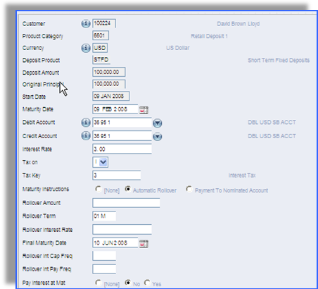  Illustration 1 - Fixed Deposit Payment Options  Additionally, included in the core module of T24, there are also Tax designer tables whereby different variety of taxes can be defined. T24 Tax Tables provide parameters for set up of Tax Types, Taxable Customer Groups, and the linkages in between.
 | Accounting entries for Unclaimed should be passed individually for each account |  | 5 | Supported by T24. Temenos T24 has built in functionality to ensure that the integrity of the accounting entries are maintained. In some instances where the accounting entries are accepted standards and any breach will go against the accepted principles of accounting, T24 ensures that the proper accounts are created automatically.  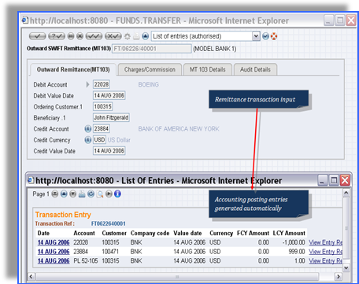  Illustration 2 - Accounting Entries
 | Ability to restrict transactions only through e-Banking, ATM and clearing. Any customer initiated transaction at “Teller” level to charge a service fee automatically. |  | 5 | Supported by T24.
 | Require a method to identify a customer as "bad" when issuing a cheque book to that customer. System should give a message when issuing a cheque book to that type of customers |  | 4 | Require interface to World Check.
 | Ability to issue cheque books containing cheque leave upto 5000 |  | 5 | Handled by T24 Cheque Issue facility.
 | Transaction uploads to the system from text files should generate an advice to the customer. |  | 4 | Uploads are supported using Temenos Open Connectivity Framework (TOCF). However, there may be some minor customization on the file and advice formatting.
 | The system to auto generate a standard letter to the instructing party for pay-orders outstanding for more than 6 months.  These letters should be generated only when customer accounts are debited. |  | 4 | Local enhancement may be required.  T24 Delivery module provides a standard letter format as a template which NDB can use to amend to suit its required format.
 | Payorder reconciliation process must be an automated. Also lost payorder to be transfer to unclaimed must be automated after the given period. |  | 4 | Local enhancement required.
 | A text field in Limits screen to identify the type of the facility. (TOD or POD) |  | 5 | Supported by T24.
 | GL inquiry to display the double entry.User should be able to see the double entry of any transaction. |  | 5 | Supported by T24.
 | Facility to issue Bankers Cheques by debiting a GL of any branch from another branch. |  | 5 | Supported by T24
 | Transaction narrations to be validated as per the given format |  | 5 | T24 has facility to check any inputs to the core fields whether they are correctly inputted or not based on the fields characteristic
 | If the transaction is between the same customer to produce only one advice with both details. |  | 5 | Supported by T24.
 | Customer ID to be a part of Account Number |  | 5 | Supported by T24.
 | Transfer of accounts within branches without changing the account number |  | 5 | T24 provides functionality to transfer account(s) from one branch to another. Transfer of account from one relationship officer to another can be simply effected by amending the account officer field on the account.
 | Provision of a reference field on all transaction screens to state the Special Transfer Prices received from treasury. This is required to calculate transfer pricing at transaction level. |  | 5 | Supported by T24.
 | Debit tax charge to be excluded for specific transactions. Eg .ATM transfers,Internet, own accounts. |  | 5 | Supported by T24.
 | Apply account holds by uploading a text file and removal of account holds manually that has been put the the system. |  | 4 | Uploads are supported using Temenos Open Connectivity Framework (TOCF). However, there may be some minor customization on the file formatting.
 | Unpaid cheque numbers to be deleted automatically at the time of closing the account. |  | 4 | Minor local customization required to effect automatic deletion.  Presented (encashed) cheques, returned cheques and stopped cheques are recorded in the Cheque Register. Lost and cancelled cheques can be recorded as stopped cheques using the Payment Stop application with different Payment Stop Types respectively.  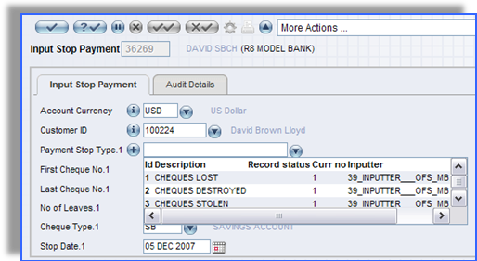  Illustration 3 - Cheque Stop Payment
 | The size of the operating instructions to allow 2000 characters |  | 4 | Operation instructions will require local enhancement as per discussion during the POC.
 | Security allocation & Swift message generation for Repo transactions. System to facilitate the following functions:  1. Securities (Bills/Bonds) to be allocated for each Repo transaction from the Bank's portfolio  2. Once allocated those securities to be excluded from the portfolio & a Report to show the balance securities available for trading  3. Swift messages to be generated for Security re-positioning MT 542 (Deliver free) at the time of deal booking  4. Subsequent reversal of Securities at the time of Repo maturity & Swift messages . |  | 5 | Supported by T24 Repo Module.
 | Customers repo investments cannot be viewed in Online banking (NBO), there should be a XML coding to pick it through NBO. |  | 5 | A standard enquiry is available to display the investments information.  The enquiry can be saved as CSV, HTML or XML format or printed out.  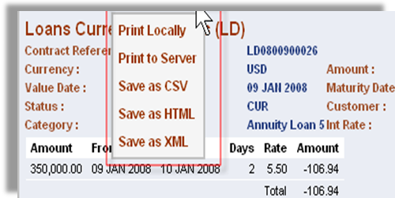  Illustration 4. Export method
 | Advices to be generated for Monthly interest debits and the detailed breakdown of the charge to be shown in the advice. |  | 5 | T24 has a module called Delivery module which handles the formatting and auto generation of different types of advices.
 | REPO's to be placed in joint names and advices printed in joint names.  If two customers jointly put a repo the advice should indicate both names. |  | 5 | One name need to be the principal for validation such as limit checking while the other can be included for information purpose only.
 | When acceptances are booked the associated Swift messages to Bank's I.e. The MT740 to reimbursing Bank and the MT799 to presenting bank to be system generated. |  | 5 | Supported by T24.
 | Setup dealer limits in the system. For Eg: Transactions exceeding limits to be prompted to a Dealer with higher level of authority (limit) prior to authorization at the Treasury Operations. |  | 4 | Require local enhancement.
 | Facility to assign dispatch codes at account level and print the customer statements by grouping together. Eg: Retain statements,Staff, Airmail etc. |  | 5 | Handled by Posting Restriction feature in T24.
 | Ability to open a notional Cash Pool for interest computaion. In this situation unlike in above zero balancing, the funds are not moved physically between accounts. Interest calculation for grouping accounts with notional pooling rquired for many customers(due to debit tax ) |  | 5 | Handled by Interest Compensation Account Hierarchy functionality. This was described in more detail in the main rfp.
 | Facility to capture the cheque details individually when teller enters the account number into the data entry screen and encode the amount on the cheque using an encoder.(Cheque deposits to be updated in the system at the point of encoding - to avoid duplication of efforts) Accommodate both options-option1- OCS interface, Option 2 - input total at F/E, B/E to reopen the batch & input details followed by the encoding. Interface for encoder - file format to be given to the bank for analysis. Bank to discuss and revert on possibility f using Flexcube for cheque deposists in branches. |  | 4 | Require some local enhancement.
 | Staff account viewing - Profile for HR Manager & Salary Staff |  | 0 | T24 is a core banking system and does not provide any functionality to support personnel management.
 | Online report to be provided for HR Manager & Salary staff. |  | 0 | T24 is a core banking system and does not provide any functionality to support personnel management.
 | 1. Provision to charge commission on FCY cash withdrawals  2. Ability to charge different buying and selling rate for FCY transactions in FCY account. |  | 5 | Fully supported by T24.  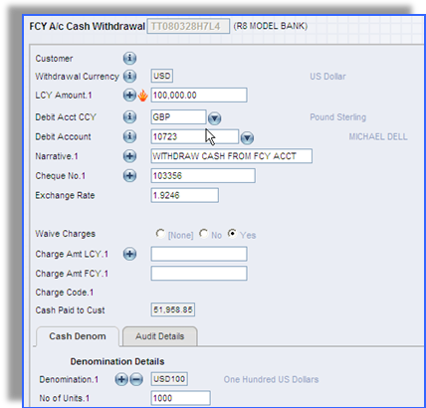  Illustration 5 - Cash Withdrawal from FCY Account
 | Multiple settlement Account cannot be accommodated in Bills |  | 5 | Supported in T24.
 | Multiple settlement Account cannot be accommodated in single bill liquidation. |  | 5 | Supported in T24.
 | If the automatic recovery of bank charge(eg service fee) are greater than the account balance, the recovery should be only the available balance in the account. In this situation system should automatically issue a letter to customer about the "nil" balances of the account and automatic closure. (Automatic Closure not required). Advice need to inform customers zero balance. |  | 5 | If automatic closure is not required, then supported by T24 with nil or minimal customization.
 | Ability to restrict transactions only through e-Banking. ATM and clearing. Any customer initiated transaction at "Teller" level to charge a service fee automatically. |  | 5 | T24 supported. System provide parameter table to define charge/fee for specific transaction. T24 also provide Open Financial Service (OFS) module to develop connection with other systems like ATM, internet banking, mobile banking
 | Advanced Export Bill on Due date, if money is not recived from Nostro, to debit customer account and contain as collection Bill with the same reference number. |  | 5 | Supported by T24.
 | Maturity Date Extention of discounted Bills as Diff rate, before and after Maturity |  | 5 | Supported by T24.
 | Customer Profitabilty Report |  | 5 | Handled by similar standard T24 MIS reports and enquiries.
 | Calculation of 364 method in T-Bills |  | 5 | We are assuming this refer to the interest basis calculation. T24 supports Actual over 364 basis method.
 | Option to Track limit of Usance period instead of LC Tenor |  | 5 | Handled in T24 Limit sub-system.
 | L/C amendemnts for reduction should not reverse until confirmation comes from the advising Bank. |  | 5 | Supported by T24 TF module.
 | Generation of MT 740 when the Documents are received |  | 5 | Supported by T24.
 | Charges and interest in Credit currency terms for Export purchases |  | 5 | Supported by T24.
 | Accurual of Discount ? Premium on Yield basis for Securities Deals |  | 5 | Supported by T24 Securities module.

